Project From Moonshot to Mars
Network Document

Koen Veelenturf, Remy Bien, Ruben Bras, Wouter Miltenburg, Sebastiaan Groot, Marvin Hiemstra
01-03-2013
1.0



1. Introduction
This document will describe the Network Design for the From Moonshot to Mars project. The From Moonshot to Mars project needs a (virtual) test environment in order to test the implementation. This document will cover the (virtual) equipment, network design, and some address details. The VMs will act as a RADIUS, LDAP, and Kerberos server. This implementation should be able to use single-sign-in securely and privately.

2. Equipment used
We will use the following network equipment for Project Moonshot:

8 VMs containing:
A minimum of 2GB RAM per VM
A minimum of 20GB storage per VM
5 of those VMs need 2 ethernet interfaces
3 of those Vms need 1 ethernet interface
13 IP4 addresses (we will integrate IPv6 in this project if time permits this)

Client equipment:
6 notebooks/laptops for project members

3. Network Topology
Below you see a schematic scheme of the network topology that is used in this project.
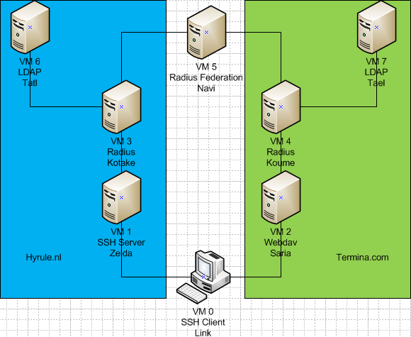

4. Virtual Machines Design
In this chapter we will describe the tasks for every Virtual Machine.

4.1 VM0 - Link
SSH client

Specifications Virtual Machine:
2GB RAM
20GB storage

4.1 VM1 - Zelda
SSH server in the hyrule.nl realm.

Specifications Virtual Machine:
2GB RAM
20GB storage

4.2 VM2 - Saria
Webdav in the termina.com realm.

Specifications Virtual Machine:
2GB RAM
20GB storage

4.3 VM3 – Kotake
Radius server of the hyrule.nl realm.

Specifications Virtual Machine:
2GB RAM
20GB storage

4.4 VM4 – Koume
Radius server of the termina.com realm.

Specifications Virtual Machine:
2GB RAM
20GB storage

4.5 VM5 - Navi
Radius Federation server.

Specifications Virtual Machine:
2GB RAM
20GB storage

4.6 VM6 - Tatl
LDAP server of the hyrule.nl realm.

Specifications Virtual Machine:
2GB RAM
20GB storage

4.7 VM7 - Tael
LDAP server of the termina.com realm.

Specifications Virtual Machine:
2GB RAM
20GB storage

5. Services
In this chapter we will describe the services which every Virtual Machine is providing.

5.1 RADIUS
Remote Authentication Dail In User Service, or RADIUS for short, is a networking protocol providing authentication, authorization and accounting management. Two RADIUS servers will be installed, each with a different realm. Each realm will be available to the other realm with the help of the RADIUS Federation server.

5.2 LDAP
Lightweight Directory Access Protocol, or LDAP is an application protocol for accessing distributed directory information services over an IP network. LDAP is installed on two different servers and will be used in combination with the RADIUS server of that domain to enable authentication on that domain.

5.3 SSH
SSH, or Secure Shell, is a cryptographic network protocol for secure data communication, remote shell services or command execution and other secure network services between two computers connected to a network, via a secure channel over an insecure network. SSH uses public-key cryptography to authenticate the remote computer and allow it to authenticate the user, if necessary. Anyone can produce a matching pair of different keys (public and private). The public key is placed on all computers that must allow access to the owner of the matching private key. The owner keeps this private key secret. While authentication is based on the private key, the key itself is never transferred through the network during authentication.
Source: http://en.wikipedia.org/wiki/Secure_Shell

5.4 WebDAV
WebDAV, or Web Distributed Authoring and Versioning, is an extension of the Hypertext Transfer Protocol that facilitates collaboration between users in editing and managing documents and files stored on web servers. The WebDAV protocol makes the Internet a readable and writable medium. It provides a framework for users to create, change and move documents on a server, most likely a web server or web share. The most important features of WebDAV are the maintenance of properties about an author or modification date, namespace management, collections, and overwrite protection.
Source: http://en.wikipedia.org/wiki/WebDAV

5.5 GSSAPI
GSSAPI (Generic Security Service Application Program Interface) is an application programming interface (API) for programs to access security services.

GSSAPI is not providing any security by itself, because it's an API and therefore an implementation you cannot provide security with GSSAPI. The implementation is provided by different security service vendors and therefore vendor independent. The GSSAPI implementation that is provided by the security service vendor is usually in the form of libraries installed with its security software. These libraries can be used to establish a security-context with the security software. Therefore, if the security implementation of the program needs to be replaced you do not have to rewrite your program that uses GSSAPI.

The definitive feature of GSSAPI application is the exchange of tokens that hide the implementation detail from the higher level application. The client and server sides of the application are written to convey the tokens given to them by their GSSAPI implementation. GSSAPI tokens can usually be sent over an insecure network as the mechanisms provide inherent message security. After some tokens have been exchanged, the GSSAPI implementations at both sides inform their local application that a security context has been established.

Once a security-context has been established, sensitive application messages can be encrypted by the GSSAPI for secure communication between the client and the server. Typical protections that are guaranteed by GSSAPI encrypted include the following:
- Confidentiality (secrecy)
- Integrity (authenticity)

